Marac data: guidance for Maracs

Contents

- About Marac data collection

- Collecting and uploading your data

- Error messages when uploading your data

- Viewing and downloading your data

- Marac data descriptions

About this guide

This guide contains information for Maracs about collecting data to contribute to SafeLives’ National dataset, and using the SafeLives Marac Data Platform to upload or view that data. For those who have responsibility for submitting data to SafeLives, guidance is available on how to upload data (sections 2 and 3). The remaining sections will be relevant to everyone who has a log-in to the Platform and would like to view their Marac data.

If you do not have a log-in for the platform but would like one, please contact marac@safelives.org.uk. Please note that if you are not the Marac Chair, Administrator or Coordinator we will need to receive permission from the Marac Chair or a member of the Marac Steering Group to set up an account for you. The Marac chair or steering group member can give permission by e-mailing marac@safelives.org.uk.

If you have any questions about this guide or about Marac data please contact the Marac data team on marac@safelives.org.uk.

About Marac data collection

Why should I collect Marac data?

We believe that by contributing to SafeLives Marac data collection you will benefit in a number of ways:

- SafeLives will analyse and return your data quarterly, providing comparison data using most similar forces, region and national data
- The analysis will help you to understand how the Marac is performing by looking at key performance indicators such as volume, against expected rates.
- You will be able to track the impact you have on the victims’ safety, through the repeat victimisation rate
- The data will track the range of agencies making Marac referrals, thereby promoting accountability and consistency between agencies
- The data will assist you in monitoring the diversity of referrals compared to the local population
- The data can be used to evidence the needs of your local population to support funding applications and commissioning of services.

Collecting a national Marac dataset also allows SafeLives to track the demand on Maracs and identify and address common issues at a strategic level. We use the data to inform government and develop policy to support you in your work.

Collecting and uploading your data

To collect and submit Marac data to SafeLives, you will need to complete the Marac data template after every Marac meeting, or use the form or grid on the SafeLives Marac Data Platform to submit the meeting data.

Marac meeting data should be uploaded to the SafeLives Marac Data Platform by the end of each quarter. The quarters are:
- Quarter 1: January to March
- Quarter 2: April to June
- Quarter 3: July to September
- Quarter 4: October to December
Generally the deadline will be one week after the quarter has ended in Q1, Q2 and Q3, and two weeks after Q4 to allow for the Christmas holidays. If you have an account on the platform that allows you to upload data, the platform will send you an automatic notification to remind you to upload data after quarter end. Please note to avoid clogging up your inbox, you will not receive an automatic notification if you have already submitted meeting data for your Marac with at least one date in each of the three months for that quarter. The platform automatically detects if there are months with no meeting data in the most recent quarter and sends out automatic reminders only to those where at least one month of the three is missing.

Uploading data

There are now three different ways you can upload data to our new platform which you can find here. Choose the one that suits you. The new platform no longer requires you to upload historical data, just the data for the new meetings each quarter. These are the ways you can upload data:

- File upload – uploading a csv or .xslx (excel) using the Marac template sheet which you can download from here. This sheet contains the new data points that we have begun to collect. The descriptions and guidance for all metrics including the new ones can be found in section 5 below.
- Form submission – adding one meeting at a time using a form to submit information
- Data grid submission – adding new meetings to your existing data displayed in a grid.

You only need to upload your data using one of these upload methods. Details of each method are below.

File upload

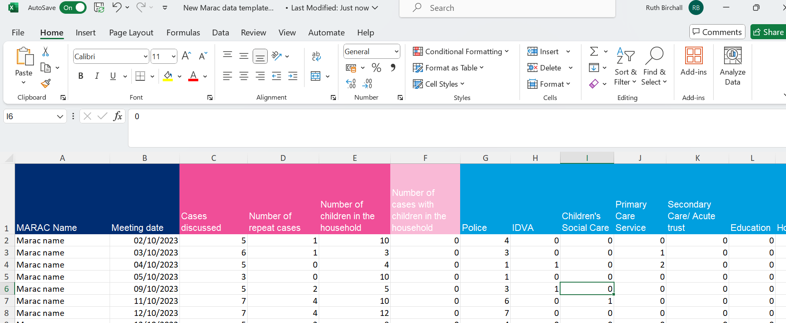

- To complete a file upload you will need to have your data stored in a Marac data template excel sheet. This will look like the above. Make sure this excel sheet only contains data for the current quarter and no historical data that has already been submitted. You can check what raw meeting data is already held on the platform for your Marac(s) by looking on the Data Grid (see below in the Data grid section for how to do this).

- Make sure the Marac name in Column A matches exactly to the name on our platform. The names are case sensitive so make sure the capitals are in the correct places, and there are no spaces at the end. If the names do not match those on the Marac Data Platform exactly, the system will not be able to read your data and it will be blocked from uploading to the platform (see Section 3 for the error messages the Platform shows when the Marac name is not right in Column A).

- If you are responsible for collecting and uploading the data for more than one Marac, you can now collect and upload all the data for the current quarter in one excel template sheet. Just make sure each row of meeting data has the right Marac name in Column A for the system to be able to read the data correctly and assign it to the right Marac.

- Once you have filled in the data, save your excel document as a csv or .xlsx. Go to file > save as and press save. Your document is now saved which can be uploaded onto our system:
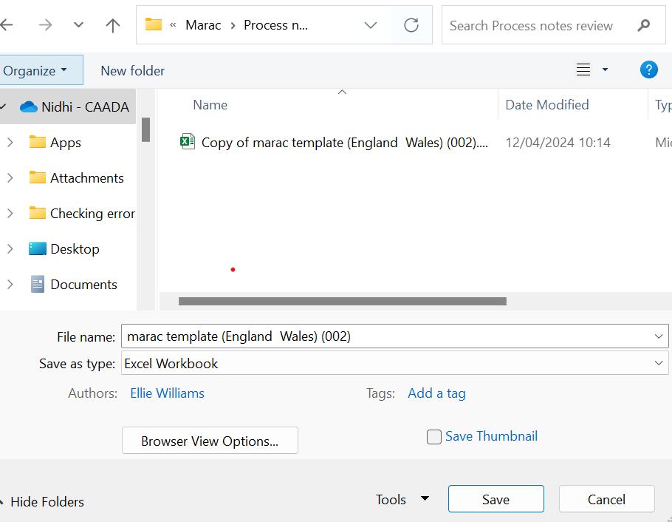

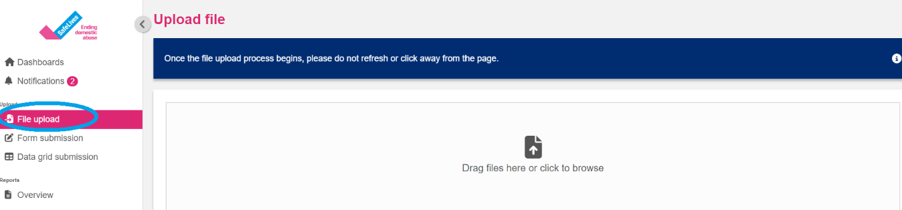

- Log on to our platform here. After you have logged on you will land on the Dashboard, select ‘File Upload’ from the left hand menu, as pictured above.

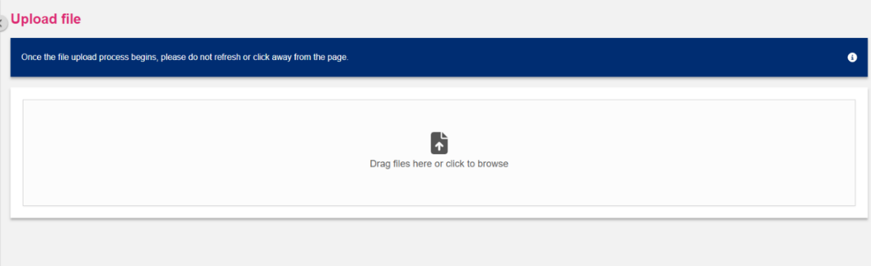

You will then be on the file upload page which will look like the image above. Click where the blue circle is. This will bring up your files.

- Browse to where you have saved your csv/.xlsx document containing your data. Select the document you would like to upload and press open. Your file will now upload.

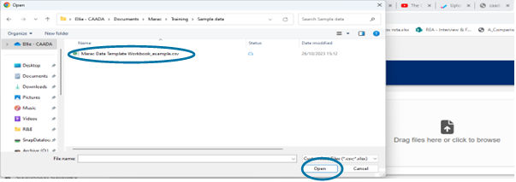
- If your data has been submitted successfully your screen will display that all records have submitted with no issues:

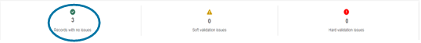

The platform does a number of automatic checks on uploads to quality assure the data. If there are issues with your data, these will be highlighted under the yellow triangle for ‘soft validation’ issues and the red circle for ‘hard validation’ issues. If there are any red validation issues the data will not be submitted. The errors will be listed below this box on the platform, identifying what row in your excel template the error occurred in. You will need to correct the errors in these rows and re-submit the data.

See section 3 below for some of the error messages you might encounter and for help with fixing them.

Form submission

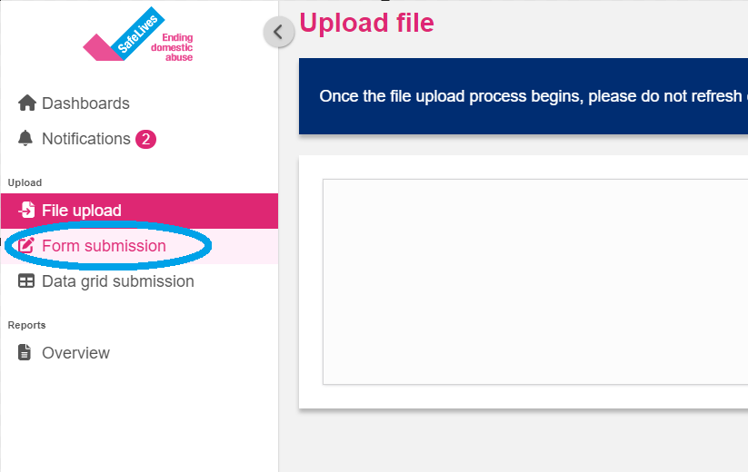

- Log on to our platform here. After you have logged on you will land on the Dashboard view, select ‘Form submission’ on the left-hand menu.

- This will take you to the page below. Data for each meeting will need to be uploaded separately.
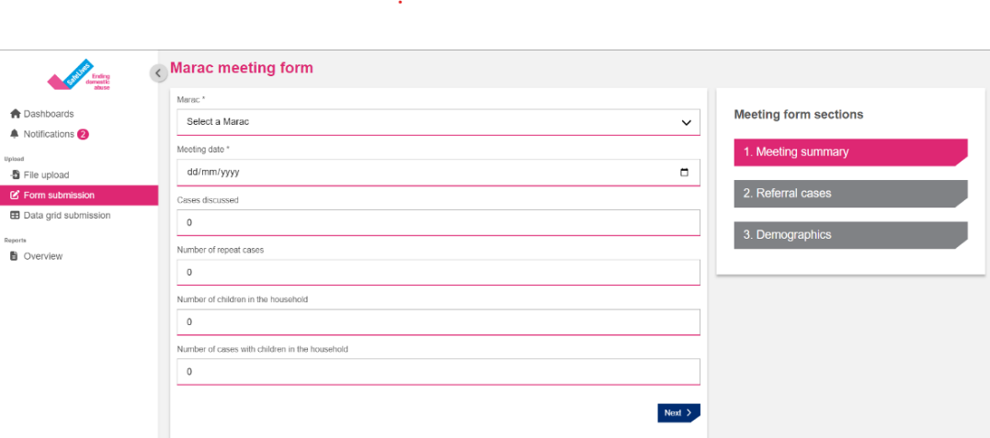

- Select the Marac you will be uploading meeting data for using the dropdown menu.

- Select the meeting date:

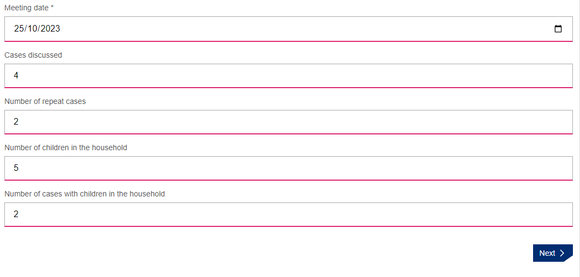
- Continue entering the data, like the example above.

- Press ‘next’ and fill in the data on the next page for the referral routes for that Marac meeting.

- Press ‘next’ and fill in the demographic data for the cases heard at that Marac meeting.

- Once you have filled all three sections, press submit at the bottom of the demographic data page. See below.

- Make sure you press submit or your data will not be saved

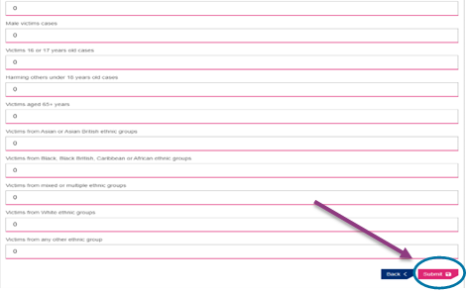

- Follow this process for each Marac meeting that took place in this quarter, making sure to ‘submit’ each form after it has been completed.

- You can check each Marac meeting has been uploaded successfully by looking in the Data grid explained in the section below.

Data grid submission

- Log on to our platform here. After you have logged on you will land on the Dashboard view, select ‘Data grid submission’ on the left-hand menu.
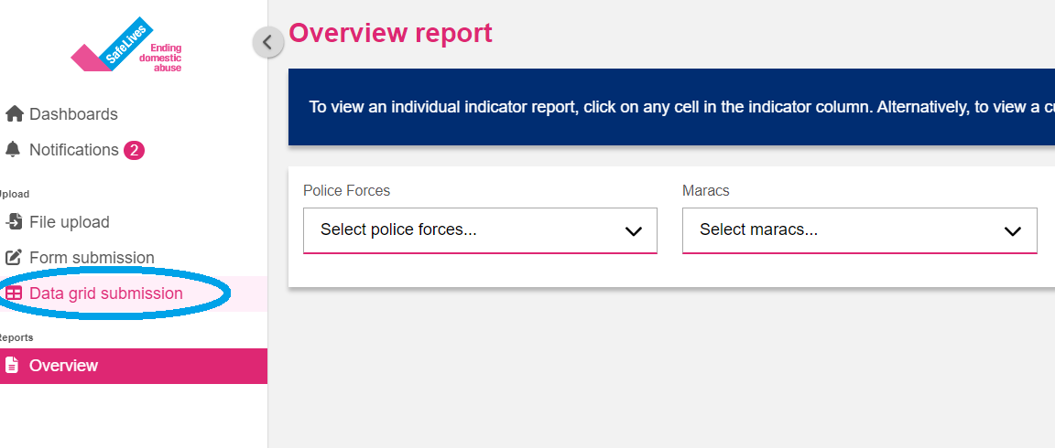

- You will see a page that looks like this. This grid contains all the data you have submitted.

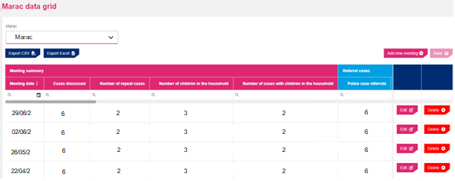

- Select the Marac you will be entering data for in the drop-down list (if you only submit data for one Marac your Marac will be automatically selected – this section is only necessary if you submit data for more than one Marac)

- Once you have selected the Marac you are adding meeting data for press add new meeting. This will create a new row in the grid that is blank as shown below, you will be filling this in.
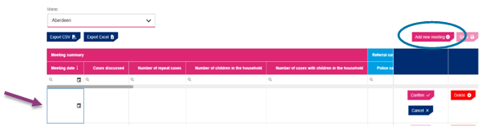
- Add the date of the meeting to the first square in the form dd/mm/yyyy, like below:

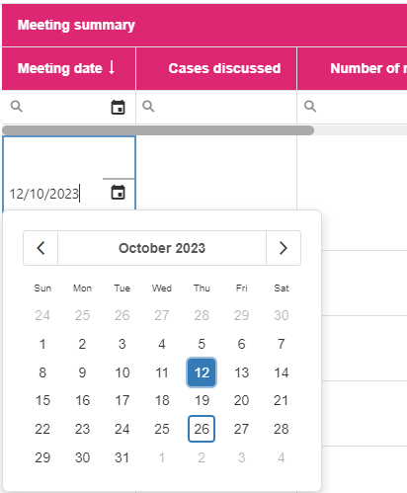

- Continue to fill in the data for the new row. Use the grey bar at the top to move across the grid until you have filled in all the data finishing at the demographic data which is the grey part of the grid.

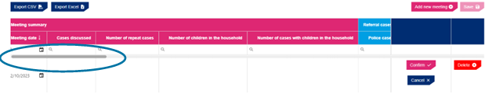

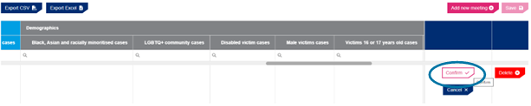
- Once you have filled in the whole row in the grid press confirm, as above.

- Follow this process for all meetings held in this quarter. Once all meetings have been added for the quarter or before you leave the page press save (which is next to add new meeting) – you must press save before leaving this page or the data will be lost
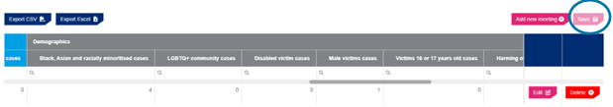

You can also use the data grid to change any data that has been uploaded wrongly.

- Find the row that the error is in using the date of the meeting.
- Find the box the error is in.
- Press edit on that row.
- Change the data in the box that the error is in.
- Press confirm.
- Press save.

You will not be able to delete any rows of data that have been uploaded incorrectly. If you need to delete any rows of data, email us at marac@safelives.org.uk and we’ll delete the data for you.

Error messages when uploading your data

With the new system, there is no need to upload historical data. The data should only contain the latest quarter of data. The system will accept data going back as far as two and a half years - any further than that and there will be at least one 'hard validation' error, which will show under the red triangle:
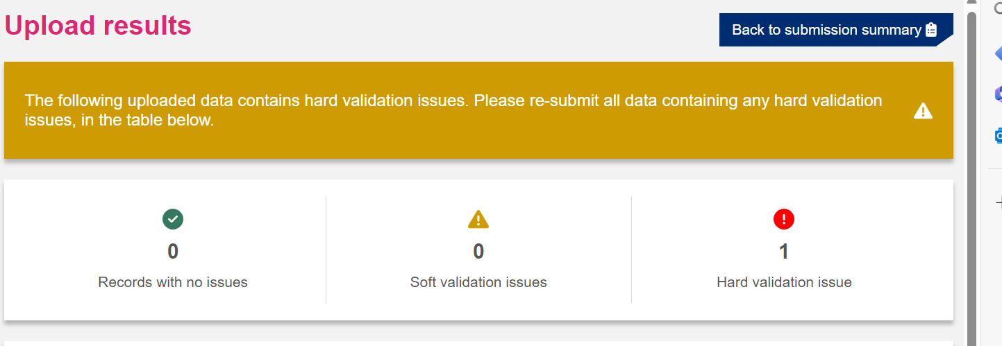
If this occurs, you need to go into your excel template and delete out the historical data.

If you submit data for dates that have previously been submitted to the system (within two and a half years) and there are differences in the data you are uploading compared to that already on the platform, you will receive at least one 'soft validation' error, which will show under the yellow triangle symbol. You will need to confirm the data you have just uploaded is correct by clicking the ‘confirm’ button at the top of your screen. The platform will display the rows and the values it has found that do not match between the meeting data already on the platform and the data you have just uploaded. If the data you have just uploaded is not correct, change the data in your current excel template so it is accurate before uploading again. However, unless you need to make changes to previous data uploaded onto the platform, there is no need to upload any historical data – you only need upload the meeting data for the quarter/s you have not previously submitted.

Some of the most common ‘validation’ issues encountered when uploading:

Example 1. User is not assigned to Marac and the new Marac does not exist in the system

Meeting date

What does it mean?

This error indicates that the system is not able to match the Marac name in your file to the one in our system. There are usually two reasons for this:

A space before or after your Marac name: If looked at closely at the example above, there is a gap after ‘New Forest’. The system flags an error as it does not identify the Marac. A way to solve it is to ensure there is no gap following the Marac name.

The name our system has for your Marac doesn’t match the name used in your spreadsheet.

How do I fix it?

A space before or after your Marac name: Go to the top of the column with your Marac name. Check that the cursor is immediately after your Marac name. Drag this cell down to the last entry.

Differences in name of Marac – to find the correct name for your Marac is download your spreadsheet from the ‘Data grid submission’ tab and check in the tab what name we use

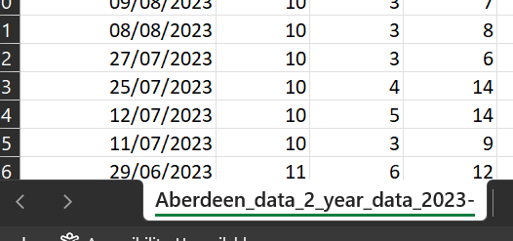

TIP: You can use the TRIM function in excel and copy-paste this formula- TRIM (text) – to ensure there are no gaps following the Marac name before you upload your file.

Example 2: Number of cases discussed failed validation.
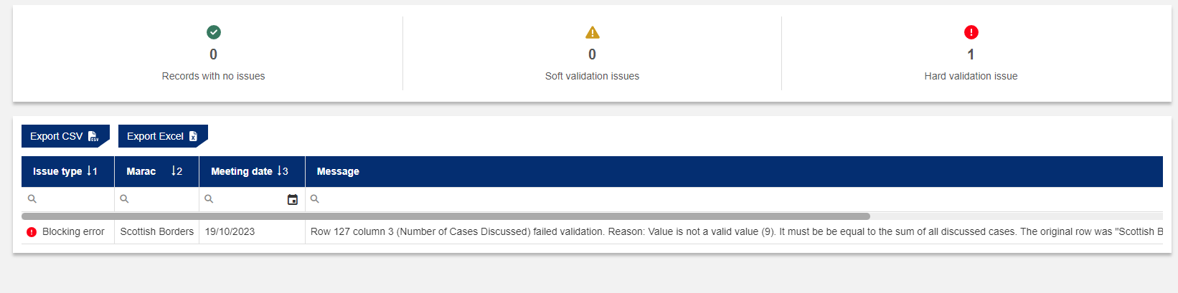

Marac name

What does it mean?

This error indicates that the number of referral routes does not match the number of cases discussed.

What does it mean?

Check if the number of referral routes sum up to the number of cases inputted. You can do this by selecting across the row in your excel document from police referrals to other referrals and check the sum number at the bottom tab in Excel is equal to the number of cases discussed in that row. If it is not equal to the number of cases discussed you will need to amend either your number of referrals or the number of cases discussed.
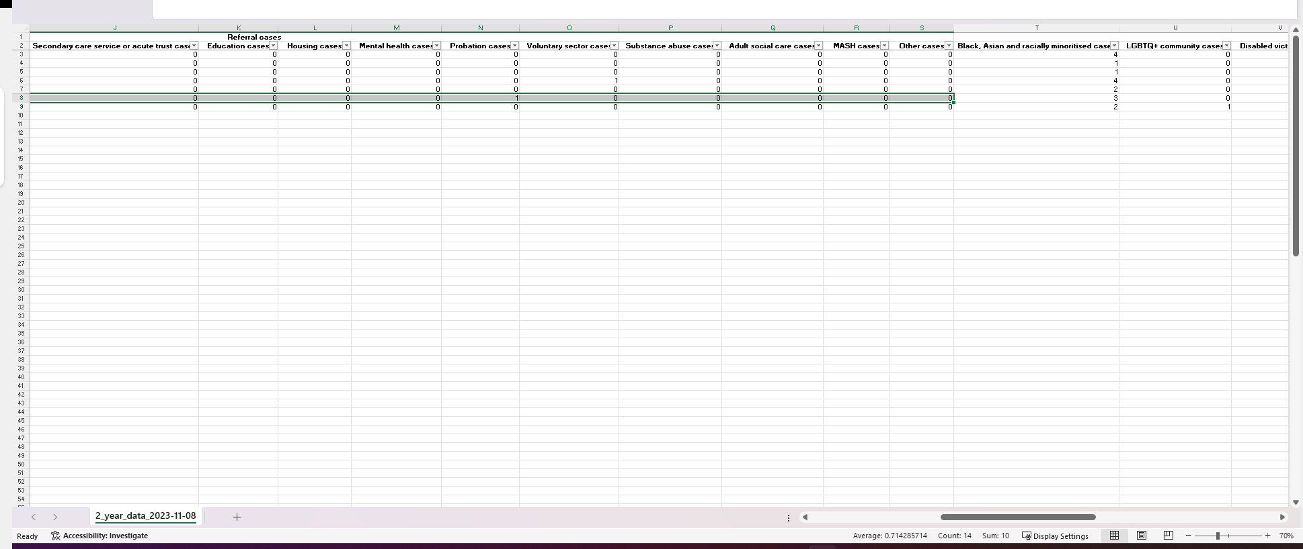

You can also use the SUM function in ‘Number of cases discussed’ in your excel sheet to avoid any errors during upload.

Example 3. Row (x) failed validation

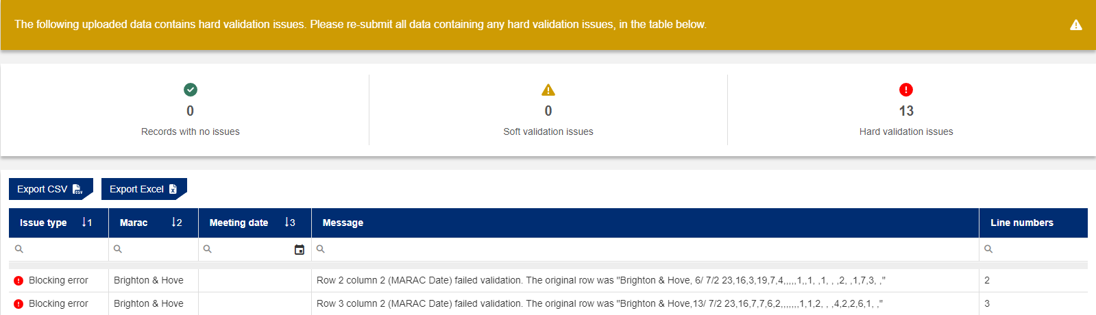
Marac name
Marac name
Marac name
Marac name

What does it mean?

How do I fix it?

Ensure there are no blank cells in your spreadsheet by replacing them with zeroes. You can use the ‘Find and Replace’ function in Excel or following the steps below.

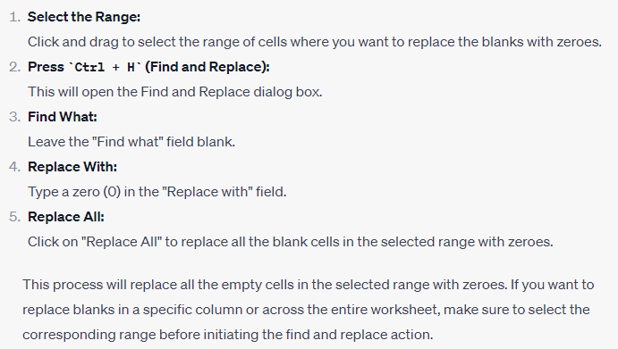

Viewing and downloading your data

You can view or download your data at any time by logging into the Marac Data Platform. If you do not have a log-in for the platform but would like one, please contact marac@safelives.org.uk.

Please note that if you are not the Marac Chair, Administrator or Coordinator we will need to receive permission from the Marac Chair or a member of the Marac Steering Group to set up an account for you. The Marac chair or steering group member can give permission by e-mailing marac@safelives.org.uk.

Viewing your Marac data

We publish data analysed as 12 months of data, named by the quarter the data ends in e.g. Q4 2023 is the 12 months of data that ends in October, November, December of 2023.

There are three places to view data now on the platform:

- Dashboard – click on the tabs at the top (goes pink). You’ll get the published data for each Marac, plus comparison charts, all downloadable. Click on each indicator for the individual charts.

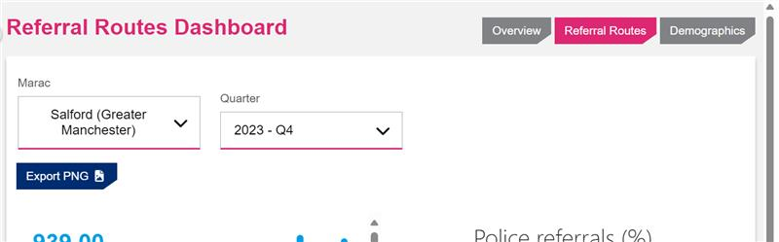

The Dashboards for each Marac are good for developing a quick view of how the Marac is running in terms of case volumes, referrals from different agencies and demographic detail alongside other related, comparable Maracs, plus the national and regional figures for each indictor. Useful for being able to create shared understanding among partners using data visualisations for how the Marac is running.

- Data grid – this is where the meeting level data can be viewed to see what we hold for Maracs; use the grey scroll bar to move across to see the all the data categories. Also downloadable.

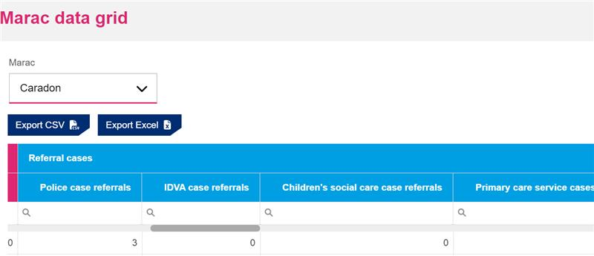

This section is good for getting hold of raw data. It goes back two and a half years. It can be used to make corrections, as well as to analyse the data in each quarter in excel.

- Overview section – click on the Marac tab to see the marac level analysis, plus comparison levels of analysis for benchmarking. This can be exported as an excel workbook, as well as being able to click in individual cells to generate specific charts and tables for particular agencies (it has instructions to do this on the portal)

Marac Chair view:

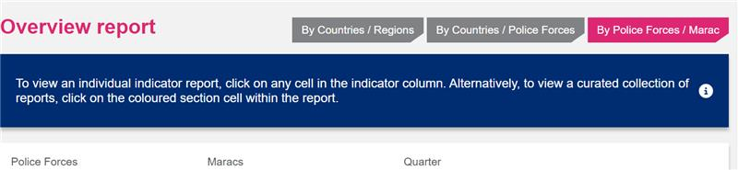
Marac Admin view:

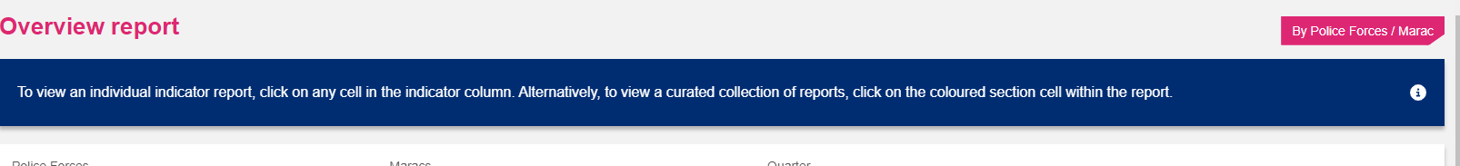

This section produces tables of data, analysed at different levels with recommended figures provided, useful for downloading data for steering groups and needs analysis.

Marac data descriptions

This section contains the definitions of each item of Marac data that we collect. This is useful to consult when there are questions from partners about how to count and record cases being discussed at Marac to ensure data quality:

Marac Name | This is the name of the Marac that the data relates to. If you are collecting and uploading data for more than one Marac, you can upload data for all your Maracs in one excel template file so long as each row of data has the right Marac name recorded in Column A for the platform to recognise. If you’re not sure what name the Marac is known by at SafeLives, log into the website here and have a look at what it is called on the drop down menu. The Marac names in Column A in excel sheets used to upload data must match the names on the system exactly and there must be no blank spaces at the end of each name for the platform to read the data successfully. Make sure there are no extra rows or columns of data added into in your excel sheet otherwise the file will not upload.  You can also upload data without an excel template now using the form or grid submission options, by selecting the Marac from the drop down menu. See our uploading guidance for extra help.
Date of Marac | This is the date the Marac meeting was held; all other columns in the row will be completed in relation to cases heard at that meeting date.  All the data for cases discussed on that meeting date must be entered on the same row. There cannot be more than one row of data for a single date. If two rows of data for the same date are entered, one row is likely to be overwritten by the other on the platform.  If, for any reason, a Marac is not held please enter the date on which it should have been held and then enter ‘0’ across the whole row.  You only need to upload data for dates which are not already on the system. You can check and edit what data is already held for your Marac on the grid.  If you are a new Marac: Put the date of your first Marac in the date held column.  If you are an existing Marac but submitting data for the first time: Put the date for the first Marac for which you have continuous records. For example, if you have been running for 3 years but only started collecting data in January, then enter the date of the January Marac and follow with subsequent meetings.
Number of cases discussed | This is the total number of cases that were discussed at this Marac meeting – this includes new cases, repeat cases and cases where the victim is aged 16 – 17 years.
Number of repeat cases | This is the number of cases seen at this Marac which come under the definition of a ‘Repeat’ as explained below:  SafeLives defines a ‘repeat’ as ANY instance of abuse between the same victim and perpetrator(s), within 12 months of the last referral to Marac.  The individual act of abuse does not need to be ‘criminal’, violent or threatening but should be viewed within the context of a pattern of coercive and controlling behaviour.  Some events that might be considered a ‘repeat’ incident may include, but are not limited to:  - Unwanted direct or indirect contact from the perpetrator and/or their friends or family  - A breach of police or court bail conditions  - A breach of any civil court order between the victim and perpetrator  - Any dispute between the victim and perpetrator(s) including over child contact, property, divorce/ separation proceedings etc.  These events could be disclosed to any service or agency including, but not exclusive to, health care practitioners (including mental health), domestic abuse specialists, police, substance misuse services, housing providers etc.
Number of children in the household | The number of children in the household is counted as the number of children normally expected to be in the house on a regular basis and who would therefore be affected by domestic abuse. Those in long term care would be excluded, and short term included.  A child is defined as anyone aged 17 or under who is not themselves referred as a victim or the person causing harm. If a woman is pregnant this would not be recorded as an additional child. Children from both new and repeat cases should be counted in this column.
Number of cases with children in the household | This used to capture the number of case where children are normally expected to be in the house on a regular basis and who would therefore be affected by domestic abuse.Those in long term care would be excluded, and short term included.  A child is defined as anyone aged 17 or under who is not themselves referred as a victim or the person causing harm. If a woman is pregnant this would not be recorded as an additional child. Both new and repeat cases should be counted in this column.
Referring Agency | Please record here which agency made the referral of each case to the Marac.  The total of all the referral route columns for the row should be equal to the total number of cases discussed at that Marac. The system will not allow you to upload data where these numbers don’t match.  If you have a case where the referral came from more than one agency at the same time, please enter each agency as fraction of 1 e.g. if it came from two agencies at the same time, please enter it as 0.5 of a referral in each agency’s column. If the referral came from three agencies, note two of them at 0.3 and the remaining agency as 0.4; this is so that the total adds up to 1. It doesn’t matter which agency you note a 0.4 as this will make little difference to the data.  If you have a Marac to Marac referral, please record this as the original referring agency.  If an agency completes the RIC and identifies that the case meets Marac threshold but refers to Marac through a different agency, this should also be recorded under the original referring agency.  If you have any agency which refers to MARAC regularly but is not listed on one of the columns, please put it in the ‘other’ column.  Categories of agencies:  • Police  • Idva / Idaa (Scotland) –This includes Idvas / Idaas from charitable and statutory organistions  • Childrens Social Care / Children and Families Social Work (Scotland) – Also known as Children and Young People’s Services  • Primary Care Services – This normally includes referrals from Community Based Health Services, e.g. Midwives, Health Visitors, School Nurses, GPs, etc. Dentists, Opthamologists and Pharmacists are also part of Primary Care.  • Secondary Care / Acute Trust – This includes all hospital based services, e.g. Accident & Emergency, Obstetrics, Elderly Medicine, Sexual Health (GUM) Clinics etc.  • Education – this includes referrals from Schools or Education Welfare Officers  • Housing – This includes Housing and Homelessness organisations – both voluntary and statutory  • Mental Health – This includes community and hospital based mental health services and mental health charities.  • Probation /Justice Social Work (Scotland)  • Voluntary Sector – This includes other specialist DV services and any non-statutory body that is not included elsewhere on this spreadsheet. This also includes specialist Black, Asian and racially minorised / LGBT+ organisations from the voluntary sector. If the Idva/Idaa who refers is from a voluntary agency, it is still recorded under ‘Idva’ or ‘Idaa’ rather than under ‘Voluntary Sector’.  • Substance Abuse – This includes referrals from both voluntary and statutory Substance Abuse Agencies.  • Adult Social Care / Adult Protection (Scotland)  • MASH – Referrals directly from a Multi Agency Safeguarding Hub.  • Other – This includes any agency or organisation making a referral to Marac not included in the list above.
Number of Black, Asian and racially minoritised victims | For the purposes of this spreadsheet or data any victim discussed at Marac who is not White British is defined as being a Black, Asian and racially minoritised person. Within Northern Ireland victims discussed at Marac who are White Irish are not defined as a racially minoritised person.  For further information on cases involving Black, Asian and racially minoritised people, please see the ‘SafeLives Guidance for Multi-agency forums: Cases involving victims who are black or minority ethnic’.
Number of LGBT+ cases | This is the number of cases where the victim identifies as Lesbian, Gay, Bisexual (LGB) or Trans. We use the term plus to denote the spectrum of sexual and gender identities that people have. These may include, but are not limited to, queer, intersex, asexual, pansexual, non-binary, genderqueer, polysexual, and questioning.  The LGBT Foundation has published a good practice guidance on monitoring sexual orientation and gender identity.  For further information on cases involving LGBT+ people, including advice on data monitoring, please see SafeLives LGBT+ spotlight.
Number of cases where victim has a disability | This is the number of cases where the victim has a disability in line with the Equality Act 2010. The Act defines a person as having a disability if ‘he or she has a physical or mental impairment and the impairment has a substantial and long-term adverse effect on his or her ability to carry out normal day-to-day activities’  This means that, in general:  - the person must have an impairment that is either physical or mental  - the impairment must have adverse effects which are substantial;  - the substantial adverse effects must be long-term;  - the long-term substantial adverse effects must be effects on normal day-to-day activities.  This can be identified by either the victim themselves or a professional who has met with/worked with them.  More information and guidance can be found in SafeLives guidance on disability and SafeLives Spotlight on Disability
Number of male victims | This is the number of victims who are male, regardless of whether the perpetrator is male or female.
Number of victims aged 16 - 17 | This is the number of cases where the victim is aged 16 – 17 years old at the time the case was referred to MARAC.  Following the extension of the definition of domestic abuse to include 16 and 17 year olds, the Home Office produced guidance on using the new definition to support local areas.
Number harming others aged 17 or below | This is the number of individuals aged 17 or below behaving in harmful ways towards the victim in line with the definition of domestic abuse.  This should be based on the age of the individual when the case is referred to Marac.
Victims aged 65+ years | This is the number of cases where the victim is aged 65+ years old at the time the case was referred to MARAC.
Victims from Asian or Asian British ethnic groups | This is for the number of victims who are from an Asian or Asian British ethnic group as defined by the high-level ONS ethnic groupings. This ONS grouping includes Bangladeshi, Chinese, Indian, Pakistani or Other Asian.
Victims from Black, Black British, Caribbean or African ethnic groups | This is for the number of victims who are from a Black, Black British, Caribbean or African ethnic group, as defined in the high-level ONS ethnic groupings. This ONS grouping includes African, Caribbean or Other Black.
Victims from mixed or multiple ethnic groups | This is for the number of victims who are from mixed or multiple ethnic groups, as defined in the high-level ONS ethnic groupings. This ONS grouping includes White and Asian, White and Black African, White and Black Caribbean or Other Mixed or Multiple ethnic groups.
Victims from White ethnic groups | This is for the number of victims who are from a White ethnic group, as defined in the high-level ONS ethnic groupings. This ONS grouping includes White: English, Welsh, Scottish, Northern Irish or British, Irish, Gypsy or Irish Traveller, Roma or Other White.
Victims from any other ethnic group | This is for the number of victims who are from any other ethnic group, as defined in the high-level ONS ethnic groupings. This ONS grouping includes Arab or Any other ethnic group.

